Press Release
Faerch’s net-zero target has been validated by SBTi
- currently, the most ambitious in the rigid food packaging industry
30 April 2024
Faerch’s greenhouse gas (GHG) emissions reduction targets have been validated by the Science Based Targets initiative (SBTi), underlining our commitment to the ambitious 1.5°C pathway from the Paris Agreement and setting a higher ambition level for climate action in the rigid food packaging industry.
Faerch aims for Net-Zero* greenhouse gas emission for the entire business in 2040, and reducing 50% in 2030 from a 2022 base year. The validated targets are absolute targets to reduce emissions from Faerch’s own operations and across its supply chain (covering all scope 1, 2 and 3 emissions).

“At Faerch, we are determined to prove that choosing circular packaging not only tackles the packaging waste challenge - it is also the key to urgent climate action. Science is clear, we much act now to deliver considerable progress in this decade. Our very ambitious targets mark our commitment to society and our customers, and we are very proud to have obtained the validation by the SBTi. Our success will rely on collaboration across our ecosystem, including customers, suppliers, industry peers and regulators, as we create circularity and climate action together."
Lars Gade Hansen
Group CEO, Faerch

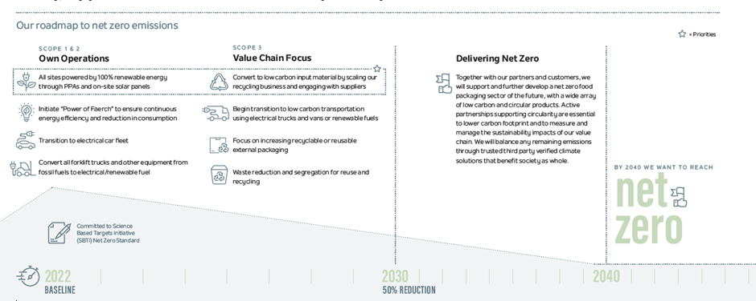

At Faerch, our commitment to sustainability and innovation has driven us forward on our journey. In order for us to meet our ambitious targets we have identified our must-win battles; scale our recycling division further, continuously increase the amount of circular content in our products and have 100% renewable energy at our sites.
Here is a glance of our transition path towards net-zero:
Scope 1 & 2: Own Operations – We want all our sites to be powered by 100% renewable energy through Power Purchase Agreements (PPAs) and on-site solar panels. We will initiate the "Power of Faerch" to ensure continuous energy efficiency and a reduction in consumption, alongside transitioning to an electric vehicle fleet and converting all forklift trucks and other equipment from fossil fuels to electrical or renewable fuel.
Scope 3: Value Chain Focus – We want to scale our recycling division and work closely with suppliers to convert to low-carbon input materials. Transportation should be moved towards low carbon alternatives, and we will have an increased focus on recyclable or reusable external packaging as well. We will also implement waste reduction and segregation for reuse and recycling at our production sites.
Delivering Net-Zero by 2040 – Our “Race to Zero” journey involves engagement with our partners and customers to develop a net-zero food packaging industry. Active partnerships supporting circularity and climate action will be instrumental to manage the environmental impacts of our value chain effectively. Any residual emissions will be neutralized in line with SBTi criteria before reaching net-zero emissions through third-party verified climate solutions, adhering to our principle of benefiting society as a whole.

“These validated targets serves as a proof-point that a company producing food packaging from plastic is able to adopt ambitious science-based targets and get them validated, as plastic material able to provide circularity will be a part of the solution. We know that delivering on our targets will be a difficult task, however setting ambitious targets, both near- and long-term, is critical to our transition efforts as they drive action to secure material impact and ensure industry-leading green offerings in this decade and a commitment to deliver net-zero to customers by 2040.”
Camilla Fangel
ESG Director, Faerch
For further insights into Faerch’s commitment to sustainability and our detailed progress, please take a look at our 2023 Sustainability Report.

*Net-Zero is defined as:
Reducing scope 1, 2 and 3 emissions to zero or to a residual level that is consistent with reaching net-zero emissions at the global or sector level in eligible 1.5°C-aligned pathways and neutralising any residual emissions at the net-zero target year and any GHG emissions released into the atmosphere thereafter.

Fact Book – Faerch’s validated targets
Overall Net-Zero Target
- To reach net-zero greenhouse gas emissions across the value chain by 2040

Near-Term Target – 2030
- To reduce absolute scope 1, 2 and 3 GHG emissions 50% by 2030 from a 2022 base year*.

Long-Term Target – 2040
- To reduce absolute scope 1 and 2 GHG emissions 90% by 2040 from a 2022 base year*.
- To reduce absolute scope 3 GHG emissions 90% within the same timeframe*.

* The target boundary includes biogenic land-related emissions and removals from bioenergy feedstocks.

About the Science Based Targets initiative
The Science Based Targets initiative (SBTi) is a global body enabling businesses to set ambitious emissions reduction targets in line with the latest climate science. It is focused on accelerating companies across the world to halve emissions before 2030 and achieve net-zero emissions before 2050.
The initiative is a partnership between CDP, the United Nations Global Compact, World Resources Institute (WRI) and the World Wide Fund for Nature (WWF) and one of the We Mean Business Coalition commitments. The SBTi defines and promotes best practice in science-based target setting, offers resources and guidance to reduce barriers to adoption, and independently assesses and approves companies’ targets.

About Faerch
Faerch is an integrated recycler – a leading supplier of circular, rigid food packaging, but also recycler of PET household waste. Faerch has more than 30 production sites, employing over 5,500 people and is owned by A.P. Moller Holding. Faerch is aiming to reach net zero emissions by 2040 across the entire value chain with focus on circular materials and renewable energy.

For further information, please contact:
Elisabet V. Sandnes
Chief Sustainability Officer, Faerch
elsa@faerch.com
+47 97 55 79 15

